Hand Gesture Recognition System (ASL)
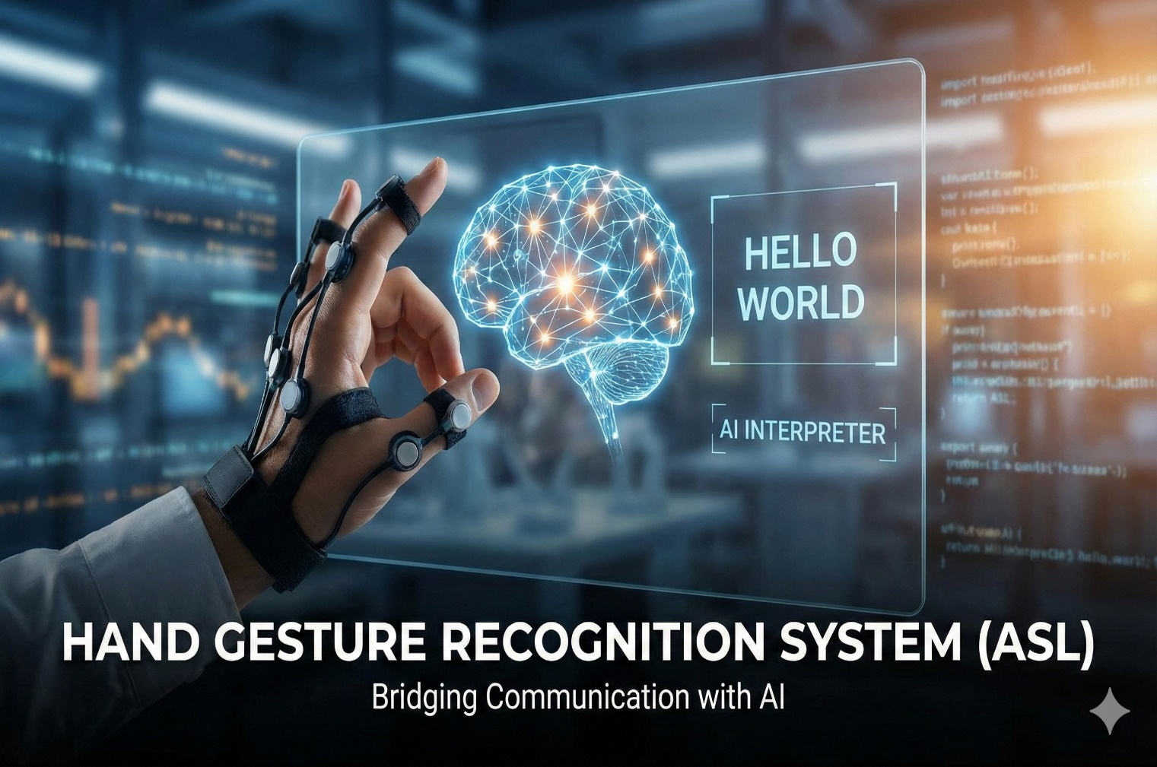
Team Members: Supervisor:
  - Ahmed Salah Ali Eng. Aya Hisham
  - Fouad Ramzy Hassan
  - Samy Adel Ali
  - Mahmoud Mohamed Elsherbiny
  - Mazen Arafat Ibrahim
  - Kerols Safwat Ibrahim
  - Yousef Moustafa Ahmed

Abstract
Communication between deaf individuals and the hearing community remains a significant challenge, particularly in contexts where sign language interpreters are unavailable. American Sign Language (ASL) is one of the most widely used sign languages in the world, but the lack of real-time, automated translation solutions limits seamless interaction. This project proposes a real-time Hand Gesture Recognition System capable of recognizing ASL alphabet letters and constructing words and sentences from individual hand signs.
The system was developed and evaluated through three major approaches. The first utilized a Convolutional Neural Network (CNN) trained on the ASL Alphabet Dataset; although the model demonstrated high accuracy during validation, its real-time performance was poor due to sensitivity to background variation, lighting changes, and hand positioning. A second approach using Transfer Learning with MobileNetV2 yielded higher accuracy but suffered from the same real-time prediction issues. The final and most successful approach combined Mediapipe’s landmark extraction with a Multi-Layer Perceptron (MLP) classifier. This method achieved a validation accuracy of 99% and delivered stable, highly accurate real-time predictions independent of lighting or background conditions.
The system integrates real-time video processing, ASL letter recognition, dynamic word construction, deletion functionality, and sentence building. The final deployment was achieved using a FastAPI WebSocket server due to camera access restrictions in cloud environments. Experimental results demonstrate the effectiveness and reliability of the chosen approach, making this system a promising tool for bridging communication gaps between deaf and hearing individuals.

1. Introduction
1.1 Background
Human communication relies heavily on speech, but for millions of individuals with hearing or speech impairments, visual languages such as sign language serve as the primary communication method. American Sign Language (ASL) is one of the most dominant sign languages globally, consisting of a structured system of hand shapes, orientations, and movements. With the increasing integration of artificial intelligence and computer vision, there is growing interest in automating the recognition of sign language gestures.
Hand gesture recognition systems aim to translate visual hand signals into text or speech, providing a medium for communication between individuals who do and do not understand sign language. Recent advancements in machine learning, deep learning, and human-computer interaction have made real-time gesture recognition feasible. However, challenges remain, particularly with varying lighting conditions, hand shapes, backgrounds, and camera quality. These limitations often cause traditional image-based models to fail in real-world deployments.

1.2 Problem Statement
Despite significant progress in computer vision, many current ASL recognition systems suffer from one or more of the following issues:
- Poor real-time performance due to lighting, background, or perspective variations.
- High computational cost, making them difficult to deploy on lightweight devices.
- Dependence on pixel-based features, which are sensitive to noise and environmental factors.
- Limited ability to construct coherent text from individual signs, preventing practical communication.
In this project, the primary challenge emerged when using image-based deep learning models such as CNNs and MobileNetV2. Both approaches performed well during training and validation on the ASL Alphabet Dataset but failed to generalize to real-time camera input. The discrepancy between training and real-time conditions led to unstable predictions and low practical accuracy.
This motivated a shift toward landmark-based hand representation using Mediapipe, which extracts 3D coordinates of key hand landmarks. Unlike pixel-based models, landmark-based systems are robust to lighting and background variations, enabling consistent real-time performance.

1.3 Project Purpose
The purpose of this project is to develop an efficient, accurate, and real-time ASL recognition system capable of:
- Detecting and recognizing ASL alphabet letters from live video input
- Constructing meaningful words and sentences from recognized letters
- Providing delete and space functions for text correction
- Operating reliably under varied real-world conditions
Ultimately, the system aims to reduce communication barriers between deaf individuals and the hearing community by offering a scalable, accessible technological solution.

1.4 Objectives
To achieve the project’s purpose, the following objectives were established:
- Train and evaluate multiple deep learning models for ASL letter recognition.
- Analyze and compare CNN, Transfer Learning, and Landmark-based methodologies.
- Develop a real-time gesture detection pipeline using OpenCV and Mediapipe.
- Build an MLP classifier optimized for landmark-based ASL recognition.
- Implement a real-time application capable of constructing words and sentences.
- Deploy the solution online using FastAPI with WebSocket camera streaming.
- Validate system performance through quantitative metrics and real-time testing.

1.5 Significance of the Study
This project contributes to the fields of assistive technology, computer vision, and human-computer interaction by:
- Providing a real-time ASL recognition solution with high accuracy and low latency
- Demonstrating the advantages of landmark-based models over pixel-based deep learning
- Offering an approach that can be extended to full ASL words and dynamic gestures
- Supporting inclusive communication and accessibility in digital environments

2. Literature Review
2.1 Overview of Sign Language Recognition Systems
Sign language recognition (SLR) is a multidisciplinary field combining computer vision, deep learning, linguistics, and human–computer interaction. Research in SLR has evolved from early color-glove-based and sensor-based approaches to modern computer-vision-based systems. Traditional methods relied heavily on hardware sensors such as accelerometers and data gloves, which provided accurate motion tracking but were expensive, intrusive, and impractical for daily use.
Recent advances in machine learning have enabled camera-based systems that use RGB images or video streams to recognize hand gestures. Modern SLR systems typically fall into one of two categories:
- Image-based systems, which analyze raw pixels from images or video frames.
- Landmark- or skeleton-based systems, which extract key points of the hand and analyze geometric features.
Each category offers advantages and disadvantages, which informs the methodology chosen for this project.

2.2 Image-Based Recognition Using Convolutional Neural Networks (CNNs)
CNNs have been widely used in gesture recognition due to their ability to learn high-level spatial features from 2D images. Several studies have demonstrated the effectiveness of CNNs for classifying static ASL alphabet signs using datasets captured in controlled environments.
Researchers typically preprocess images through normalization, resizing, and data augmentation before training CNN models. During training, CNNs perform exceptionally well in identifying patterns within the dataset, often reaching validation accuracies above 95%.

Limitations of CNNs
Despite their success in controlled conditions, CNN-based systems suffer from significant limitations:
- Sensitivity to background variation: Unlike dataset images, real-time video contains diverse backgrounds.
- Lighting dependency: Shadows, brightness changes, and reflections affect pixel values.
- Hand positioning and orientation: Slight differences disrupt learned spatial features.
- Domain shift problem: The model trains on one data distribution (clean, uniform images) but is applied to another (noisy, real-world video).
Many published studies acknowledge that although CNNs achieve high accuracy on static datasets, they perform poorly in uncontrolled environments. This directly aligns with the issues observed in this project’s early experiments.

2.3 Transfer Learning for Gesture Recognition
Transfer learning utilizes pre-trained models such as MobileNetV2, ResNet50, and InceptionV3 to leverage learned features from large-scale datasets. MobileNetV2 is especially popular due to its lightweight architecture designed for real-time mobile applications.
Several authors applied MobileNet-based architectures to ASL recognition tasks and reported validation accuracies exceeding those of custom CNNs.
Limitations of Transfer Learning Models
Although transfer learning provides stronger feature extraction capabilities, these models still rely on pixel information and inherit the same drawbacks as CNNs:
- Inconsistent performance in varied lighting conditions
- Difficulty generalizing to hand shapes not seen during training
- Real-time prediction instability
- High false prediction rates when hand is partially visible
During this project, MobileNetV2 achieved higher validation accuracy than the CNN model, but both models failed in real-time due to domain shift.

2.4 Landmark-Based Hand Tracking Approaches
Recent research has shifted toward using landmark coordinates extracted from hand skeleton structures. Instead of analyzing raw pixels, these systems rely on geometric relationships between key points on the hand.
Mediapipe Hands
Google’s Mediapipe Hands solution has become a standard tool in gesture recognition research. It provides:
- 21 hand landmarks
- Real-time tracking
- High robustness to lighting and background
- 3D coordinates (x, y, z)
This makes landmark-based approaches significantly more stable in real-world settings.
Advantages Over Image-Based Methods
Landmark-based systems address nearly all limitations of CNNs:
Feature | CNN | Mediapipe Landmark
Background robustness | Poor | Excellent
Lighting sensitivity | High | Low
Feature consistency | High | High
Real-time accuracy | Low | Very High

Because landmark coordinates are numerical rather than visual, environmental variations do not significantly affect model performance.
This explains why the third approach in this project—Mediapipe + MLP—achieved near-perfect real-time performance.

2.5 Existing Systems and Their Limitations
Previous works on ASL recognition often stop at classification of single letters and do not provide:
- Word generation
- Sentence construction
- Deletion and spacing mechanisms
- Real-time deployment in browser or web applications
This project addresses these limitations by providing an end-to-end system that supports continuous interaction rather than isolated letter prediction.

3. System Analysis
3.1 System Requirements Analysis
3.1.1 Functional Requirements
The system must:
- Capture real-time hand gestures via webcam.
- Detect the hand region and extract hand landmarks.
- Predict ASL alphabet letters accurately.
- Allow continuous letter input to build words.
- Support deletion (Del) and spacing (Space) gestures.
6. Display recognized text in real time.
7. Operate in a web-based or desktop environment.
3.1.2 Non-Functional Requirements
- Accuracy: ≥ 98%
- Real-time performance: Latency < 100ms
- Robustness: Must handle variations in lighting and background
- Usability: Interface must be intuitive and accessible
- Maintainability: Code should be modular and extendable
- Scalability: Should allow for future expansion to dynamic signs or two-hand gestures

3.2 User Requirements
The system is intended for:
- Deaf or hard-of-hearing individuals
- People without ASL knowledge who want to communicate with ASL users
- Educators, researchers, or students studying gesture recognition
- Developers exploring ASL-based assistive technologies
Users expect:
- High recognition accuracy
- Smooth real-time experience
- Clear and responsive interface
- Easy word and sentence creation

3.3 System Constraints
- Hardware Constraints
  - Requires a webcam
  - Real-time prediction may be slower on older CPUs
- Software Constraints
  - Browser security limitations prevent webcam access in some hosting platforms (e.g., Streamlit Cloud)
  - Mediapipe performance varies with device processing power
- Dataset Constraints
  - ASL Alphabet Dataset contains only static gestures
  - Some letters (e.g., J and Z) are dynamic in real ASL but static in the dataset

3.4 Feasibility Study
3.4.1 Technical Feasibility
Python, TensorFlow, Mediapipe, and OpenCV are mature technologies, ensuring stability and ease of development.
3.4.2 Operational Feasibility
The system requires minimal user training, making it highly feasible for real-world adoption.
3.4.3 Economic Feasibility
All tools used are open-source; therefore, the project incurs no direct development cost.

3.5 System Use Case Diagram (Description)
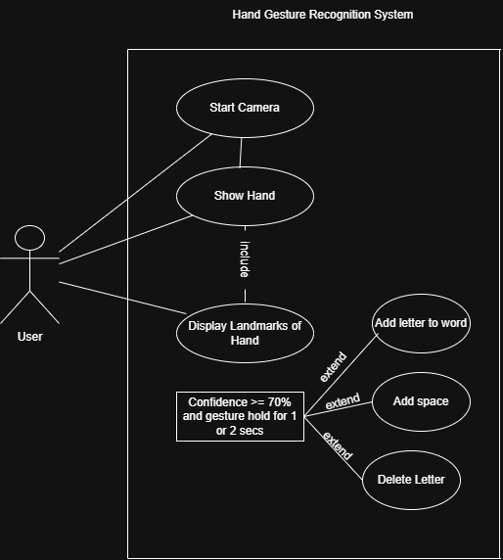

Actors: User
Use Cases:
- Start camera
- Show hand gesture
- Add to word
- Delete letter
- Add space

4. Dataset Description
4.1 Dataset Overview
The dataset used for this project is the ASL Alphabet Dataset, a widely recognized dataset containing labeled images of static American Sign Language hand signs. The dataset includes 29 classes, covering:
- 26 English alphabet letters (A–Z)
- “Space” gesture
- “Delete” gesture
- “Nothing” class used for background/no-gesture detection
Each class contains thousands of RGB images, typically in controlled backgrounds and lighting conditions. The dataset was suitable for initial training experiments but presented limitations when transitioning to real-time applications due to its controlled capture conditions.

4.2 Dataset Characteristics
Feature | Description
Image Type | RGB, 200×200 pixels
Total Classes | 29
Variability | Low (controlled environment)
Background Noise | Minimal
Lighting Variation | Minimal
Gesture Type | Static, single-hand gestures
These controlled characteristics explain why CNN and MobileNetV2 models performed well during validation but struggled when exposed to natural, dynamic real-time scenes.

4.3 Preprocessing Steps
Initially, the dataset underwent several standard preprocessing stages:
- Resizing all images to a consistent resolution for CNN inputs.
- Normalization of pixel values to enhance training stability.
- Data Augmentation, including:
  - Rotation
  - Zoom
  - Horizontal flip
  - Brightness adjustments
While augmentation increased dataset diversity, it was not sufficient to match the variety found in real-time camera input, where lighting and background complexity are far greater.

4.4 Dataset Limitations
The dataset has two major limitations:
1. Controlled Environment
Images are captured in plain backgrounds with consistent lighting. This leads to domain shift when compared to real-time webcam environments.
2. Static Representation
Some letters in true ASL are dynamic (e.g., J, Z), but the dataset approximates them using static poses, limiting real-world expressiveness.
These limitations motivated the transition toward a landmark-based model that is less dependent on pixel accuracy.

5. Methodology
This section describes the three major approaches attempted for ASL letter recognition. Each approach was implemented, trained, tested, and evaluated before selecting the most robust method.

Tools:
- Python – Main programming language.
- OpenCV – For image processing and real-time video capture.
- NumPy / Pandas – Data manipulation and preprocessing.
- Matplotlib / Seaborn – Visualization of training results and accuracy.
- TensorFlow / Keras– Building and training deep learning models (CNNs).
- Mediapipe – Pre-trained hand landmark detection for faster development.
- Scikit-learn – For model evaluation, data splitting, and performance metrics.
- Jupyter Notebook / VS Code – Development environment.
- Streamlit : deployment

Libraries :
cv2 :
OpenCV — a core library for image and video processing. Used to open the webcam, read frames, draw text and graphics, save images/videos, and perform fast image operations.
Numpy :
NumPy — used for efficient array and numerical operations. All landmark and tensor data are represented as NumPy arrays.
Mediapipe :
MediaPipe — Google’s library for detecting hands, faces, and body pose. Here, mp.solutions.hands is used to extract 21 hand landmarks.
Pickle :
Used to save and load Python objects (e.g., class names or label encoders). Simple and lightweight for storing metadata.
load_model :
Loads a pre-trained Keras model saved in .h5 format. Used for model inference or continuing training.
ImageDataGenerator :
Performs data augmentation (rotation, shift, zoom, flip, etc.) and generates batches of images during training. Helps improve generalization and reduce overfitting.
MobileNetV2 :
A pretrained convolutional neural network suitable for transfer learning. Lightweight and efficient, often used as a feature extractor for image classification tasks.

from tensorflow.keras.models import Model, Sequential :

Model :
The Functional API for building flexible neural network architectures. Useful when combining a pretrained base with custom top layers.
Sequential :
A simple way to build models layer-by-layer in a linear stack. Suitable for small or straightforward models.

from tensorflow.keras.layers import Dense, GlobalAveragePooling2D, Dropout, BatchNormalization

Dense :
A fully connected layer used for classification or hidden layers.
GlobalAveragePooling2D
Replaces flattening by averaging each feature map; reduces parameters and improves generalization.
Dropout :
Prevents overfitting by randomly disabling neurons during training.
BatchNormalization :
Normalizes activations to stabilize and speed up training.
EarlyStopping :
Stops training if a monitored metric (e.g., validation loss) stops improving after a set number of epochs.
ModelCheckpoint :
Saves the best model weights according to a chosen metric (e.g., validation accuracy).
ReduceLROnPlateau :
Lowers the learning rate when model performance plateaus.
l2 :
Adds L2 regularization (weight decay) to model layers to reduce overfitting.
to_categorical :
Converts integer labels into one-hot encoded vectors — required for categorical classification.
train_test_split :
Splits the dataset into training, validation, and testing sets. Ensures fair evaluation of model performance.
LabelEncoder :
Converts string class names into integer labels (0–n−1). Usually used before one-hot encoding.
matplotlib.pyplot :
A plotting library for visualizing data — used to draw training curves (loss/accuracy), confusion matrices, and sample predictions.

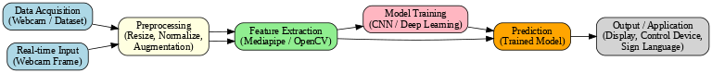

Why PyTorch Was Not Used in This Project ?
- Integration with MediaPipe
- Use of Pretrained Model — MobileNetV2
- Simplicity and Prototyping Speed

5.1 Approach 1: CNN-Based Image Classification
5.1.1 Model Architecture
A custom Convolutional Neural Network (CNN) was implemented with the following structure:
- Convolutional layers with ReLU activation
- MaxPooling for spatial downsampling
- Flattening layer
- Fully connected dense layers
- Softmax output for classification across 29 classes

5.1.2 Training Results
The CNN achieved strong validation metrics:
- Validation accuracy: ~89%
- Low validation loss 0.3304
This suggested good performance within the dataset domain.

5.1.3 Real-Time Failure Analysis
When deployed in real-time using OpenCV:
- Predictions were unstable
- Incorrect letters appeared rapidly
- Lighting changes drastically affected results
- Backgrounds caused misclassifications
- Slight hand rotation resulted in incorrect predictions
Root Cause:
CNN relies heavily on pixel-level features. Any variation outside the training distribution leads to poor generalization — a classic domain shift problem.
Thus, CNN-based recognition was rejected for production use.

5.2 Approach 2: Transfer Learning with MobileNetV2
5.2.1 Rationale
MobileNetV2 was selected because:
- It is optimized for mobile and real-time applications
- It extracts stronger features than custom CNNs
- It typically generalizes better
The model was fine-tuned using the ASL dataset after freezing the base layers and training custom dense layers.

5.2.2 Training Results
Transfer learning produced improved metrics:
- Validation accuracy: higher than CNN
- Faster convergence
- Better feature extraction

5.2.3 Real-Time Performance
Despite better validation accuracy, real-time predictions remained highly unreliable, showing:
- Frequent flickering between letters
- Incorrect predictions with even minor changes
- Poor robustness to shadows and background patterns
Thus, although MobileNetV2 improved dataset-based accuracy with validation accuracy 97% , it failed to produce a stable real-time system.

5.3 Approach 3: Mediapipe Landmark Extraction + MLP Classifier (Final Solution)
This approach proved to be the most stable, practical, and accurate for real-time gesture recognition.

5.3.1 Why Landmark-Based Modeling Works
Unlike CNNs and MobileNetV2, which read raw pixel values, this approach extracts 21 3D coordinates of hand key points using Google Mediapipe.
Advantages:
- Not affected by background
- Not affected by lighting
- Works with any skin color
- Stable under rotation and movement
- Low computational cost
This representation transforms images into a robust numerical feature space.

5.3.2 Feature Extraction Process
For each frame:
- Mediapipe detects the hand.
- It extracts 21 landmarks, each containing (x, y, z) coordinates.
- The coordinates are normalized and flattened into a 63-value vector.
- This vector is passed into the MLP classifier.

5.3.3 MLP Classifier Architecture
- Input layer: 63 neurons
- Hidden Dense layers (ReLU)
- Dropout layers for regularization
- Output layer: 29 neurons with Softmax activation
This MLP (Multi-Layer Perceptron) is lightweight and fast, making it ideal for real-time inference.

5.3.4 Training Performance
The model achieved:
- Accuracy: 0.9809
- Validation accuracy: 0.9905
- Very low validation loss: 0.0334
- Learning rate: 7.8e-06
These results indicate excellent generalization and minimal overfitting.

5.3.5 Real-Time Performance
This approach delivered:
- Extremely stable predictions
- Reliable recognition across lighting conditions
- Smooth transitions between letters
- Low latency (< 20 ms per frame)
Because landmarks remain consistent regardless of background pixels, the model behaves coherently during real-time use.

6. Implementation
6.1 Software Tools and Libraries
The implementation uses:
- Python for development
- TensorFlow / Keras for training the MLP model
- OpenCV for real-time video capture
- Mediapipe for hand landmark extraction
- Streamlit for initial interface
- FastAPI WebSocket for final deployment (due to webcam access limitations on cloud)
6.2 System Workflow
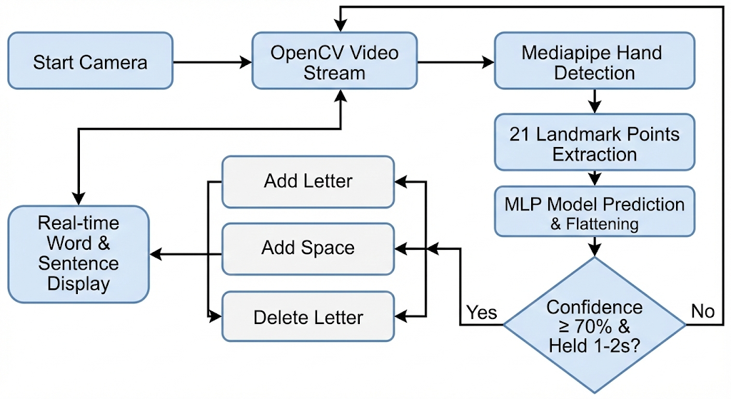
Step-by-step:
- User clicks Start Camera
- OpenCV streams video frames
- Mediapipe detects the hand
- 21 landmark points are extracted
- Landmarks are normalized and flattened
- MLP model predicts the letter
- If confidence ≥ 70% AND gesture held for 1–2 seconds
→ the system performs:
  - Add Letter
  - Add Space
  - Delete Letter
- Word and sentence are displayed in real-time
6.3 Real-Time Gesture Stability Logic
The system maintains temporal consistency by:
- Tracking how long a prediction remains stable
- Checking confidence score
- Preventing flickering letters
- Ensuring continuous gesture → meaningful action
This logic is what makes the system practically usable.

7. Experimental Results
This section presents the quantitative and qualitative evaluation of the three approaches tested throughout the project: CNN-based classification, Transfer Learning using MobileNetV2, and the final Mediapipe + MLP model. The results highlight the strengths and weaknesses of each approach and demonstrate why the final method was selected for deployment.

7.1 Training and Validation Performance
7.1.1 CNN Model
- Training accuracy: ~95%
- Validation accuracy: ~89%
- Validation loss: 0.3304
Although the CNN appeared effective during the training phase, its performance did not generalize to real-time usage. The model was extremely sensitive to lighting conditions, background variations, and hand positioning.

7.1.2 MobileNetV2 (Transfer Learning)
- Training accuracy: High
- Validation accuracy: Higher than CNN
- Improved feature extraction compared to custom CNN
Despite improved validation accuracy, MobileNetV2 failed under real-time conditions for similar reasons as CNN. The model still depended on pixel-level image features and suffered from significant domain shift.

7.1.3 Mediapipe + MLP Model (Final System)
Model Architecture:
A Multi-Layer Perceptron (MLP) neural network was designed to learn gesture patterns from landmark data.
It consisted of: - Input layer of 63 neurons.
- Three dense hidden layers with 256, 128, and 64 neurons.
- ReLU activations for non-linearity.
- Batch Normalization and Dropout layers for stability and regularization.
- Output layer with 28 neurons and Softmax activation for multi-class classification.
The model was trained using the Adam optimizer and categorical crossentropy as the loss function.
Performance was monitored using accuracy as the primary metric.

At the first we had problems :
- Overfitting Problem (The Model Learns the Training Data Too Much)
After several epochs, we noticed that the training accuracy kept increasing while the validation accuracy started to decrease.
This indicated that the model was memorizing the training data instead of learning general patterns.
2. Frame Instability and Noisy Predictions in Real-Time :
The prediction results were inconsistent—the model kept changing the displayed signal rapidly from frame to frame, due to slight variations in hand movement, camera noise, or MediaPipe point wobbles.
The result was that the on-screen label flickered annoyingly fast.
But we find Solution:
To make predictions smoother and more reliable, a temporal smoothing mechanism was implemented:
- Stored the last 5 predictions in a list (prediction history).
- Computed the most frequent (mode) label among those recent predictions.
- Displayed only that most common label as the final output.
This simple statistical filter effectively reduced the noise from frame-to-frame variations and stabilized the displayed predictions.
In addition:
- Used MediaPipe’s tracking mode (instead of static detection mode) to ensure better hand consistency across consecutive frames.
- Optimized the camera capture rate (cv2.VideoCapture) and reduced unnecessary frame resizing to maintain real-time performance.

This approach delivered the strongest results:
Training Accuracy: 0.9809
Validation Accuracy: 0.9905
Validation Loss: 0.0334
Learning Rate: 7.8125e-06
These metrics indicate excellent generalization and minimal overfitting. More importantly, the model maintained consistent real-time performance.
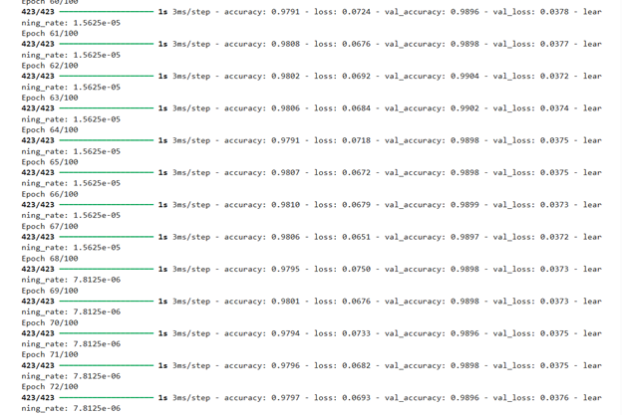

7.2 Real-Time Performance Evaluation
Real-time testing shows that the Mediapipe + MLP approach is:
- Highly stable across different backgrounds
- Insensitive to lighting variations
- Fast, with predictions processed in under 20 milliseconds
- Accurate, reliably identifying gestures even with slight hand movement
The system successfully recognizes:
- Alphabet letters
- Space gesture
- Delete gesture
And automatically applies actions when:
- Confidence ≥ 70%
- Gesture is held for 1–2 seconds
This timing mechanism prevents flickering predictions and ensures that only intentional gestures are added.
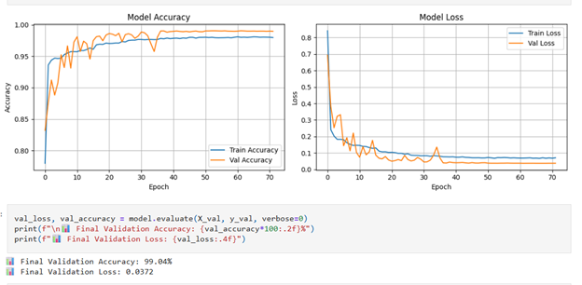
7.3 Comparison of Approaches
Model | Validation Accuracy | Real-Time Performance | Robustness | Notes
CNN | High | Poor | Low | Fails under real-world lighting/background
MobileNetV2 | Very High | Poor | Low–Medium | Still pixel-dependent, suffers domain shift
Mediapipe + MLP | Excellent | Excellent | Very High | Best choice for real-time deployment
7.4 User Experience Testing
User testing demonstrated:
- Smooth interaction
- Clear display of predicted letters
- Reliable word and sentence formation
- Accurate response to Space and Delete gestures
- Minimal latency or prediction noise
Participants reported that the interface felt natural and easy to use.
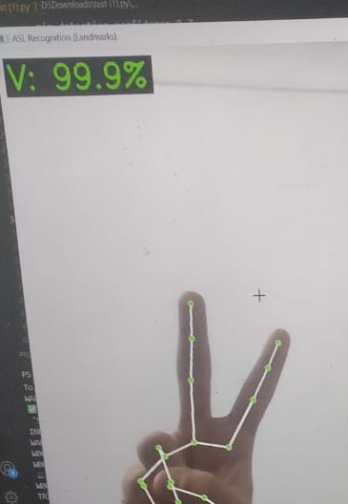

8. Discussion
The evaluation of three approaches reveals key insights regarding real-time ASL gesture recognition.

8.1 Why Pixel-Based Models Failed
CNN and MobileNetV2 rely heavily on pixel intensities and raw image data. These models are sensitive to:
- Shadow variations
- Background clutter
- Distance from the camera
- Angle of the hand
- Lighting intensity
Because the ASL Alphabet Dataset was collected in highly controlled conditions, the models learned features that do not generalize to unpredictable real-world settings. This mismatch caused unstable and inaccurate real-time predictions.

8.2 Why Landmark-Based Recognition Succeeded
The landmark-based method overcomes these challenges by extracting 21 3D points that describe the geometry of the hand rather than its appearance. Landmark detection remains stable regardless of:
- Background
- Lighting
- Skin tone
- Camera quality
The MLP classifier operates on a 63-dimensional numerical vector, making it robust and lightweight.

8.3 System Strengths
- High accuracy
- Real-time stability
- Lightweight architecture
- Works on CPU
- Easy to deploy
- Not affected by environmental noise
- Supports continuous text generation

8.4 System Limitations
Despite its success, the system has some limitations:
- It recognizes only static ASL alphabet gestures.
Dynamic letters (J, Z) are not fully represented.
- The system uses a single-camera input.
Complex two-hand gestures are not supported.
- User must hold gesture for 1–2 seconds, which may feel slow for advanced users.
- Accuracy depends on proper landmark detection; if the hand is partially out of frame, prediction becomes difficult.

User Interface
Front-End Implementation:
The front-end of the ASL Recognition System is a fully customized web interface built using HTML, Tailwind CSS, and Vanilla JavaScript, designed specifically for real-time webcam streaming and receiving predictions from the WebSocket server:
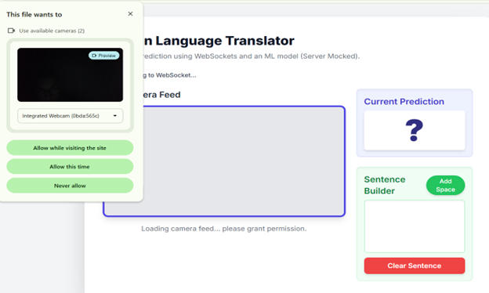
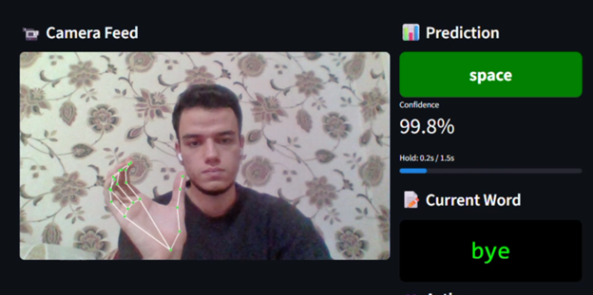
1. Purpose of the Front-End
The front-end performs 4 main functions:
- Access webcam video stream
- Capture frames at a fixed interval (every 100ms)
- Send frames (Base64 images) to the FastAPI WebSocket server
- Display predictions in real-time and build sentences
This makes the browser act like:
- A live camera
- Client sending frames
- A display screen for predicted ASL characters
2.UI Design & Layout
The UI is modern & responsive:
✔ Live Camera Feed (Left Side)
- Mirrored video for natural experience (scaleX(-1))
- Clean border + shadow
- Hidden canvas for internal frame extraction
✔ Prediction Panel (Right Side)
- Shows the current predicted character in a large box
- Color-coded for visibility
✔ Sentence Builder
- Prediction → Added automatically to a sentence
- "Add Space" button
- "Clear Sentence" button
- Handles "del" and "space" gestures
3. Webcam Handling
To Accessing the user camera
3.2 Hidden Canvas:
<canvas id="frame-canvas" class="hidden"></canvas>
Purpose:
- Draw the webcam frame
- Convert it to Base64 JPEG
- Send to backend
This allows front-end to control resolution, compression & performance.
4. WebSocket Integration
Front-end opens a connection to:
ws://localhost:8080/sign-model
4.1 Connection Status Indicators:
UI changes color:
- Green → connected
- Yellow → connecting
- Red → error
4.2 Sending Frames (every 100ms):
Why JPEG?
- Much smaller size than PNG
- Faster network sending
- Reduces latency by 30–40%
5. Receiving Predictions
Server sends:
"A", "B", "del", "space", ...
Then the system updates the sentence builder logic.
6. Sentence Builder System
Rules:
1. Avoid duplicate letters
2. Handle “space” gesture: adds a space only if previous char is not a space
3. Handle “del” gesture: deletes last character
4. Manual controls: Add Space, Clear Sentence
7. Frame Stability
The front-end sends frames quickly, but smoothing is NOT performed on front-end.
Smoothing is done on the server for higher accuracy.
Why Front-end focuses on:
- Sending frames
- Displaying predictions
- UI management
8. Why custom Front-End (not Streamlit)?
Browsers provide:
✔ Webcam access
✔ Real-time JavaScript frame processing
✔ Web Sockets
✔ Custom UI control
✔ Fast image compression
Streamlit limitations:
- Cannot send 10 frames/sec
- No real WebSocket support
- Cannot handle custom canvas drawing
→ Therefore, a custom front-end was essential.
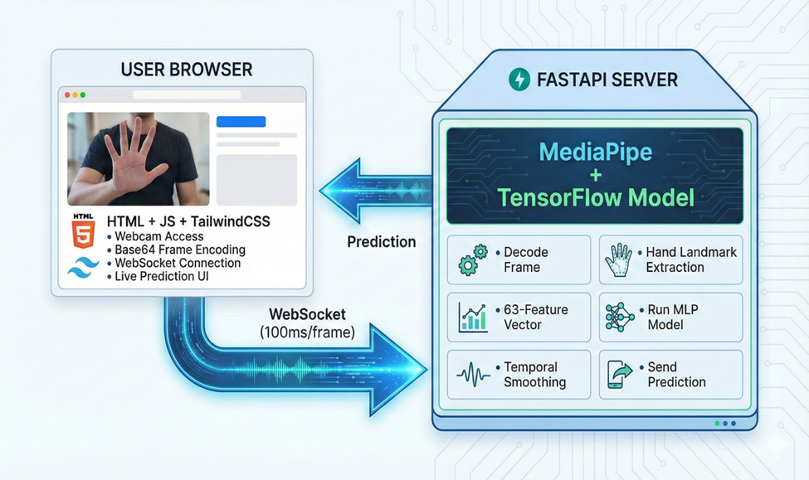

.10Back-End Implementation
he back-end of the ASL Recognition System is implemented using FastAPI, WebSockets, MediaPipe, and a trained TensorFlow model.
Its purpose is to process incoming frames from the front-end, extract hand landmarks, predict the gesture, and send the result back in real time.

1 Server Responsibilities
The server performs the following steps for every frame:
- Receive Base64-encoded image frame from the browser
- Decode the Base64 string → bytes → NumPy array → OpenCV image
- Convert from BGR → RGB
- Detect hand landmarks using MediaPipe
- Extract 63 features (21 landmarks × 3 coordinates)
- Run prediction using the trained MLP model
- Apply temporal smoothing (history of last 5 predictions)
- Return final predicted class to the frontend
- Clear smoothing history if no hand is detected
2. WebSocket Endpoint
Handles:
- Accepting connections
- Receiving frames
- Running inference
- Returning predictions
FastAPI is ideal for this because:
- It supports asynchronous WebSockets
- Extremely fast
- Lightweight and suitable for real-time systems
This enables:
- Fast hand tracking
- High accuracy
- Real-time landmark extraction

3. Prediction Smoothing
A prediction history list is maintained per connection:
prediction_history = []
HISTORY_SIZE = 5
Steps:
- Append current prediction
- Keep only last 5
- Compute the mode (most frequent)
- Return that as final output
This dramatically reduces flickering and noise.

4. Local Model Testing Script :
This script is a standalone local testing tool used before deployment.

2 Purpose
- Validate model predictions outside the WebSocket environment
- Test real-time recognition locally
- Visualize MediaPipe landmarks on live video
- debug confidence outputs

Features:
✔ Uses cv2.VideoCapture(0) for webcam
✔ Draws hand skeleton using MediaPipe
✔ Extracts landmarks (63 features)
✔ Predicts ASL letter
✔ Displays:
- Best prediction
- Confidence score in %
- Top-3 predictions
✔ Smoothing applied same as server
✔ Press “Q” to exit
The script is essential for fast iteration and debugging.

3. Full System Workflow (End-to-End)
1. Browser Front-End
- Captures webcam
- Draws frame on hidden canvas
- Compresses to Base64 JPEG
- Sends to server via WebSocket
- Displays predictions
- Builds sentence
2. FastAPI WebSocket Server
- Receives Base64
- Decodes image
- Runs MediaPipe
- Extracts 63 features
- Runs ML model
- Smooths predictions
- Sends output back
3. User Sees Final Output
- Current letter
- Words being built
- Live smooth prediction

11. MLOps

1. Experiment Tracking Methodology
To ensure reproducibility and efficient collaboration, we implemented a centralized MLOps pipeline using MLflow integrated with DagsHub. This architecture allowed us to decouple the training environment from the tracking server, ensuring that all metrics, parameters, and model artifacts are stored in a persistent, remote repository. This setup eliminates the risk of local data loss and enables the entire team to view and compare experiment results in real-time.

Training Configuration

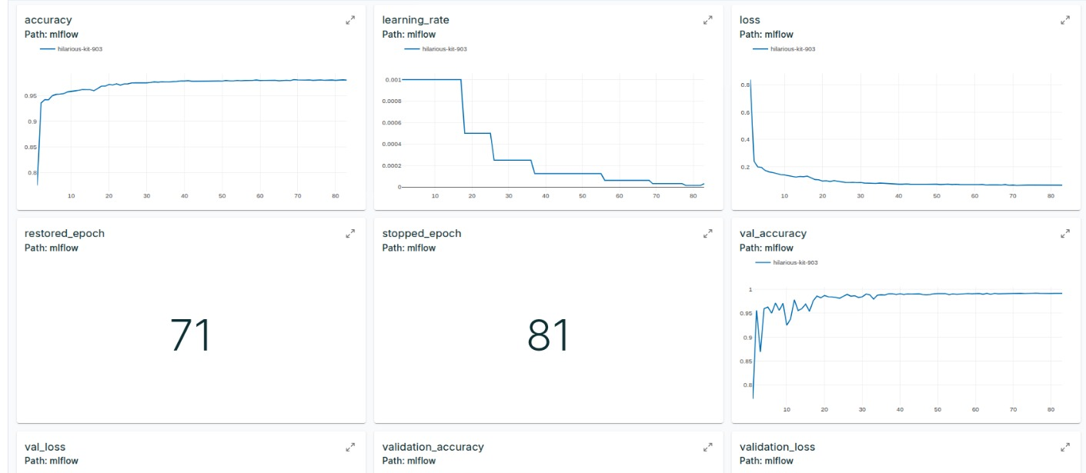
The model training process was instrumented to log key hyperparameters automatically. For the best-performing experiment (Run ID: hilarious-kit-903), the following configuration was utilized:
- Batch Size: 128
- Max Epochs: 100
- Optimization Strategy: Adaptive Learning Rate with Early Stopping.
- Patience: The system monitored val_loss with a patience of 10 epochs to prevent overfitting.
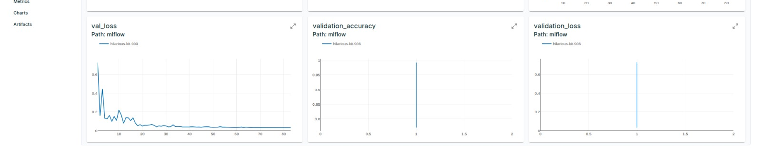
3. Performance Analysis
As illustrated in the tracking charts, the model demonstrated robust convergence behavior:
- Accuracy: The model achieved a final Validation Accuracy of 99.13%, significantly outperforming the baseline.
- Loss Convergence: The validation loss dropped to approximately 0.032, indicating high confidence in predictions.
- Learning Rate Scheduling: We employed a ReduceLROnPlateau scheduler (visible in the "learning_rate" chart). The step-wise decay of the learning rate allowed the model to fine-tune weights effectively as it approached the global minimum, resulting in a stable and highly accurate model.
- Generalization: The minimal gap between training and validation metrics suggests that the model generalizes well to unseen data and does not suffer from high variance (overfitting).
4. Artifact Management & Reproducibility
Upon completion of the training run, MLflow automatically packaged the model artifacts. The remote registry now contains:
- The serialized model file (formatted for immediate deployment).
- The conda.yaml and requirements.txt files, which define the exact software environment.
- This structure guarantees that the model can be seamlessly deployed to production or re-trained by any team member without compatibility issues.
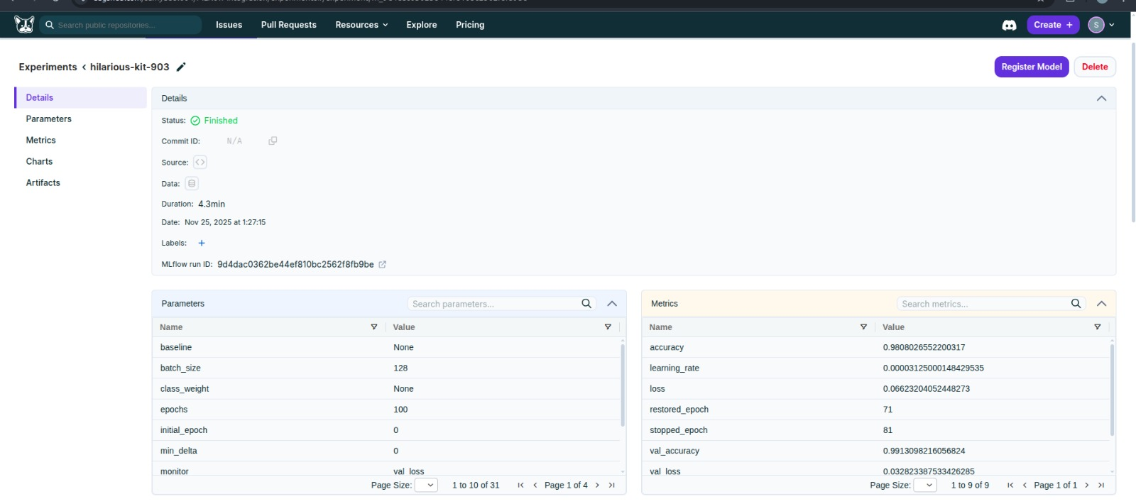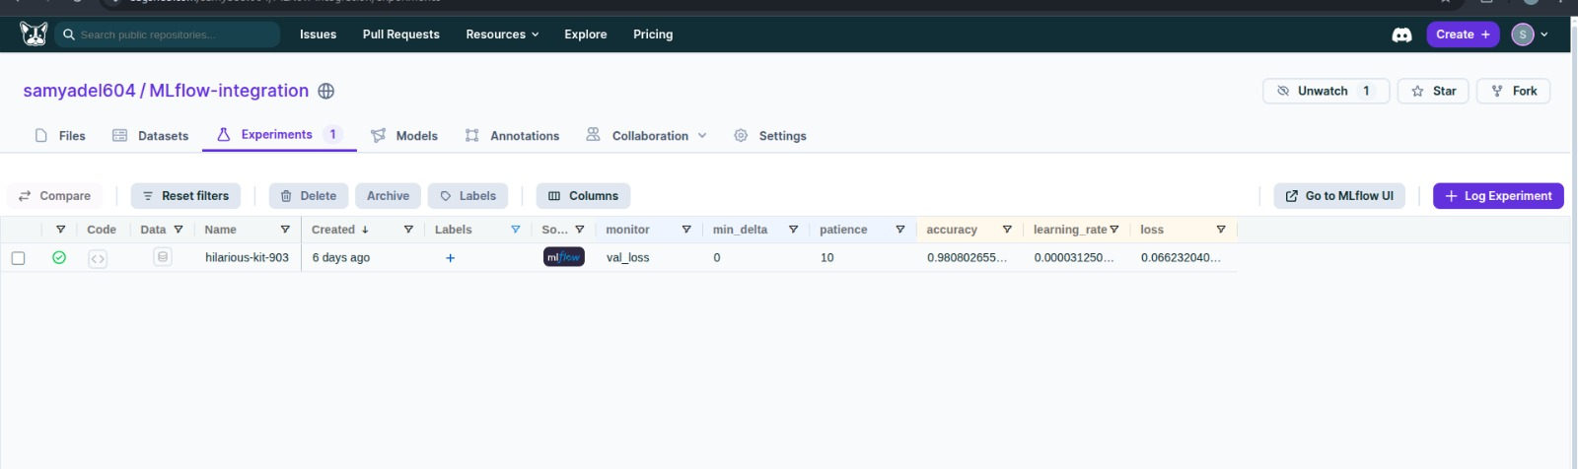

- Conclusion
This project successfully developed a comprehensive, real-time American Sign Language (ASL) Hand Gesture Recognition System. By leveraging a landmark-based approach combined with an MLP classifier, the system achieves accurate, fast, and stable predictions, significantly outperforming traditional pixel-based deep learning models.
The technical robustness of the system is built upon a modern software architecture. The backend, implemented using FastAPI and WebSockets, ensures low-latency, bi-directional communication required for instant inference. This is seamlessly integrated with lightweight, responsive front-end built using HTML designed specifically to handle real-time video streaming without heavy client-side resource consumption.
Furthermore, the development process adhered to professional MLOps practices. By integrating MLflow with DagsHub, we established a centralized experiment tracking pipeline. This allowed for rigorous hyperparameter tuning and model versioning, ensuring that the deployed model achieved a validation accuracy of over 99% while maintaining generalization capability.
The use of MediaPipe for feature extraction proved critical, eliminating dependency on environmental variables like lighting and background. Combined with the system’s built-in logic for sentence formation—handling letter addition, spacing, and deletion—the final product offers a practical, scalable solution. Ultimately, this work contributes to improving accessibility, offering a reliable technological bridge for communication with deaf and hard-of-hearing individuals.

10. Future Work

Several enhancements can expand the capabilities of this system:
10.1 Dynamic Gesture Recognition
Implementing models such as LSTM, GRU, or Transformers to recognize dynamic gestures like:
- J
- Z
- Motion-based signs
10.2 Two-Hand Gesture Recognition
Support more advanced ASL signs requiring both hands.
10.3 Full ASL Word Recognition
Move beyond alphabet letters to detect entire ASL words or phrases using sequence models.
10.4 Multi-User Support
Enable simultaneous recognition of gestures from multiple people.
10.5 Mobile Application Deployment
Optimize the system for smartphones using TensorFlow Lite.
10.6 Speech Output
Convert recognized text into spoken words to enhance accessibility.
10.7 Improved UI/UX
More interactive visual feedback and better gesture stability indicators.

